**Title: VITMeet: Connect, Collaborate, Conquer**

**Abstract:**

VITMeet is an online platform tailored exclusively for students of VIT Bhopal University. The platform aims to facilitate virtual collaboration, communication, and academic support among students. Features include chat rooms, event updates, academic assistance forums, club and society forums, campus news, mentorship opportunities, and exclusive resources.

VITMeet addresses the limitations of existing systems by providing a dedicated space for VIT Bhopal students. The project focuses on enhancing connectivity, fostering collaboration, and promoting a supportive learning environment within the university community. The platform offers real-time notifications, curated resources, and interactive forums to enrich the academic experience. VITMeet strives to empower students to connect, collaborate, and excel in their academic endeavours. Hardware and software configurations are optimized for reliability, scalability, security, and maintainability. The project aligns with the university's goals of promoting student engagement, academic success, and personal growth.

VITMeet serves as a comprehensive solution to enhance the educational journey of VIT Bhopal students.

**Introduction:**

Connectivity and collaboration are vital aspects of the academic experience, especially in today's digital age. VITMeet emerges as a response to the need for a tailored platform catering to the specific requirements of VIT Bhopal students. The platform aims to bridge the gap between students, fostering a supportive community where knowledge exchange and mutual assistance thrive. By providing dedicated features and resources, VITMeet seeks to enrich the academic journey of every VIT Bhopal student. The project emphasizes the importance of connectivity, collaboration, and support in enhancing student engagement and academic success. VITMeet strives to create an inclusive and interactive environment where students can connect, communicate, and collaborate seamlessly.

* Through VITMeet, students can access a wide range of features and resources designed to enhance their learning experience.
* The project aligns with the university's commitment to fostering innovation, excellence, and student-centered education.
* VITMeet aims to empower students to take ownership of their learning journey and succeed academically.
* The introduction sets the stage for VITMeet as a transformative platform that redefines how students collaborate and engage in their education.

**The objective of Project:**

* The primary objective of the VITMeet project is to facilitate seamless virtual collaboration among students of VIT Bhopal University.
* The project aims to address the need for a dedicated platform tailored to the specific requirements of VIT Bhopal students.
* VITMeet seeks to enhance connectivity, foster collaboration, and promote a supportive learning environment within the university community.
* The project focuses on empowering students to connect, communicate, and collaborate effectively on academic endeavours.
* By providing dedicated features and resources, VITMeet aims to enrich the academic journey of every VIT Bhopal student.
* The project emphasizes the importance of student engagement, academic success, and personal growth within the university community.
* VITMeet aligns with the university's goals of promoting innovation, excellence, and student-centered education.
* The project seeks to create an inclusive and interactive platform where students can connect, collaborate, and thrive academically.
* Through VITMeet, students can access a wide range of tools, resources, and opportunities to enhance their learning experience.
* Overall, the objective of the VITMeet project is to empower VIT Bhopal students to excel academically and beyond.

**Existing Systems:**

* Existing systems often lack specificity tailored to the unique needs of students within VIT Bhopal University.
* Generic platforms may need to adequately cater to the curriculum, events, or resources relevant to VIT Bhopal students.
* There is a need for a dedicated platform like VITMeet to address the limitations of existing systems.
* VITMeet offers specialized features and resources designed specifically for the VIT Bhopal student community.
* Existing systems may lack the interactivity, collaboration tools, and support mechanisms required for effective student engagement.
* VITMeet aims to fill this gap by providing a comprehensive platform that meets the specific needs of VIT Bhopal students.
* The project seeks to enhance connectivity, foster collaboration, and promote academic success within the university community.
* By addressing the shortcomings of existing systems, VITMeet aims to create a more inclusive and supportive learning environment.
* VITMeet offers a range of features, including chat rooms, event updates, academic assistance forums, and exclusive resources, not available in current systems.
* Overall, VITMeet represents a significant advancement over existing systems by providing a tailored solution for VIT Bhopal students' academic needs.

**Proposed Project:**

* VITMeet is a comprehensive online platform tailored exclusively for students of VIT Bhopal University.
* The project aims to facilitate virtual collaboration, communication, and academic support among students.
* VITMeet offers a range of features, including chat rooms, event updates, academic assistance forums, and exclusive resources.
* The platform addresses the limitations of existing systems by providing a dedicated space for VIT Bhopal students.
* The project focuses on enhancing connectivity, fostering collaboration, and promoting a supportive learning environment within the university community.
* Through real-time notifications, curated resources, and interactive forums, VITMeet enriches the academic experience for students.
* The platform empowers students to connect, communicate, and collaborate effectively on academic endeavours.
* Hardware and software configurations are optimized for reliability, scalability, security, and maintainability.
* VITMeet aligns with the university's goals of promoting student engagement, academic success, and personal growth.
* Overall, VITMeet represents a transformative platform that redefines how students collaborate and engage in their education.

**Hardware Configuration:**

* Servers: Power the web application, handle user requests, and manage data processing.
* Storage Systems: Store user data, chat logs, and other application-related information securely.
* Networking Equipment: Facilitate communication between servers, ensuring seamless data transfer.
* Load Balancers: Distribute incoming traffic evenly across multiple servers to prevent overload.
* Redundant Power Supplies: Ensure continuous operation by providing backup power in case of outages.
* RAID Storage Arrays: Enhance data reliability and performance through disk mirroring or striping.
* Data Center Racks: Organize servers and networking equipment efficiently within the data centre.
* Cooling Systems: Maintain optimal temperature levels to prevent overheating and hardware failures.
* Firewalls: Protect the network from unauthorized access and malicious threats.
* Intrusion Detection Systems: Monitor network traffic for suspicious activities and potential security breaches.

**Software Configuration:**

* Real-time: Enables instant communication and interaction between users in the chat environment.
* WebRTC: Facilitates peer-to-peer audio and video communication directly in web browsers.
* Socket.io: Manages real-time bidirectional communication between the client and server.
* Next.js: Provides a framework for building React applications with server-side rendering capabilities.
* MongoDB: Stores and retrieves data using a flexible, document-based NoSQL database system.
* Firebase: Offers real-time database, authentication, and cloud functions for serverless logic.
* Redis: Handles caching, messaging, and session management for improved performance.
* React UI Library: Utilizes reusable UI components to create a responsive and intuitive user interface.
* Scalable: Designed to handle growing user demand by efficiently allocating resources.
* Security: Implements encryption, authentication, and access control mechanisms to protect user data and ensure privacy.

**Functional Modules:**

* Chat Rooms: Dedicated spaces for students to engage in discussions related to courses, assignments, and academic interests.
* Event Updates: Real-time notifications and updates about campus events, workshops, seminars, and academic activities.
* Academic Assistance Forums: Platforms for students to seek or offer help with coursework, assignments, projects, and exam preparation.
* Club and Society Forums: Forums for members of student clubs, societies, and organizations to collaborate on initiatives and projects.
* Campus News: Updates and announcements about the latest news and developments within VIT Bhopal University.
* Mentorship Opportunities: Platforms for students to find mentors or become mentors, guiding and supporting their peers in academic and personal growth.
* Exclusive Resources: Access to curated educational resources, including study materials, academic journals, and research databases.
* User Profiles: Personalized profiles for students to showcase their interests, skills, and academic achievements.
* Notifications and Reminders: Automated notifications and reminders for upcoming events, deadlines, and tasks.
* Admin Dashboard: A centralized dashboard for administrators to manage users, content, and system settings.

**Literature Review:**

* "Real-time Communication Technologies for Web Applications": This paper explores various real-time communication technologies such as WebRTC, Socket.io, and Firebase, discussing their implementation in web applications and their impact on user experience.
* "Scalability and Performance Optimization in WebRTC-based Applications": This paper investigates techniques for optimizing the scalability and performance of WebRTC-based applications, including load balancing, media server deployment, and bandwidth management strategies.
* "Security Considerations in Real-time Web Applications": This paper examines security challenges and best practices for real-time web applications, covering topics such as data encryption, authentication mechanisms, and protection against common security threats like cross-site scripting and SQL injection.
* "Next.js Framework: Features, Performance, and Use Cases": This paper provides an in-depth analysis of the Next.js framework, highlighting its features, performance characteristics, and potential use cases in building modern web applications.
* "MongoDB Database: Advantages, Limitations, and Best Practices": This paper evaluates the MongoDB database system, discussing its advantages, limitations, and best practices for data modelling, querying, and scalability.
* "Firebase Realtime Database: Architecture, Performance, and Scalability": This paper explores the architecture, performance characteristics, and scalability of the Firebase Realtime Database, analyzing its suitability for building real-time web applications.
* "Redis in Web Development: Caching, Pub/Sub, and Session Management": This paper examines the role of Redis in web development, focusing on its capabilities for caching, pub/sub messaging, and session management, and their impact on application performance and scalability.
* "React UI Libraries Comparison: Performance, Accessibility, and Developer Experience": This paper compares different React UI libraries, evaluating their performance, accessibility features, and developer experience to help developers choose the most suitable library for their projects.
* "Load Balancing Strategies for Real-time Web Applications": This paper investigates load balancing strategies for real-time web applications, comparing different approaches such as round-robin, least connections, and IP hashing, and their effectiveness in distributing traffic across server instances.
* "Intrusion Detection Systems for Web Application Security": This paper discusses the role of intrusion detection systems (IDS) in enhancing web application security, examining various IDS techniques and their effectiveness in detecting and mitigating security threats such as SQL injection, cross-site scripting, and DDoS attacks.

**Use Case Diagram for Project:**

**Actors:** Students, Administrators, Moderators, Mentors

**Use Cases:**

Log in

Join Chat Room

Create Chat Room

Send Message

View Event Updates

Post Academic Assistance Request

Respond to Academic Assistance Request

Join Club/Society Forum

Post Announcement

Access Exclusive Resources

Update Profile

Administer Users

**Relationships:**

Students interact with Chat Rooms, Events, Academic Assistance Forums, Club/Society Forums, and Resources.

Administrators manage Users, Announcements, and System Settings.

Moderators oversee Chat Rooms and Forums.

Mentors provide guidance and support to other students.

**Interactions:**

Students log in to access platform features.

They can join existing chat rooms or create new ones.

Students can engage in discussions, seek assistance, and participate in events.

Administrators manage user accounts, post announcements, and configure system settings.

Moderators monitor chat rooms and forums, ensuring compliance with community guidelines.

Mentors offer guidance and support to students seeking assistance.

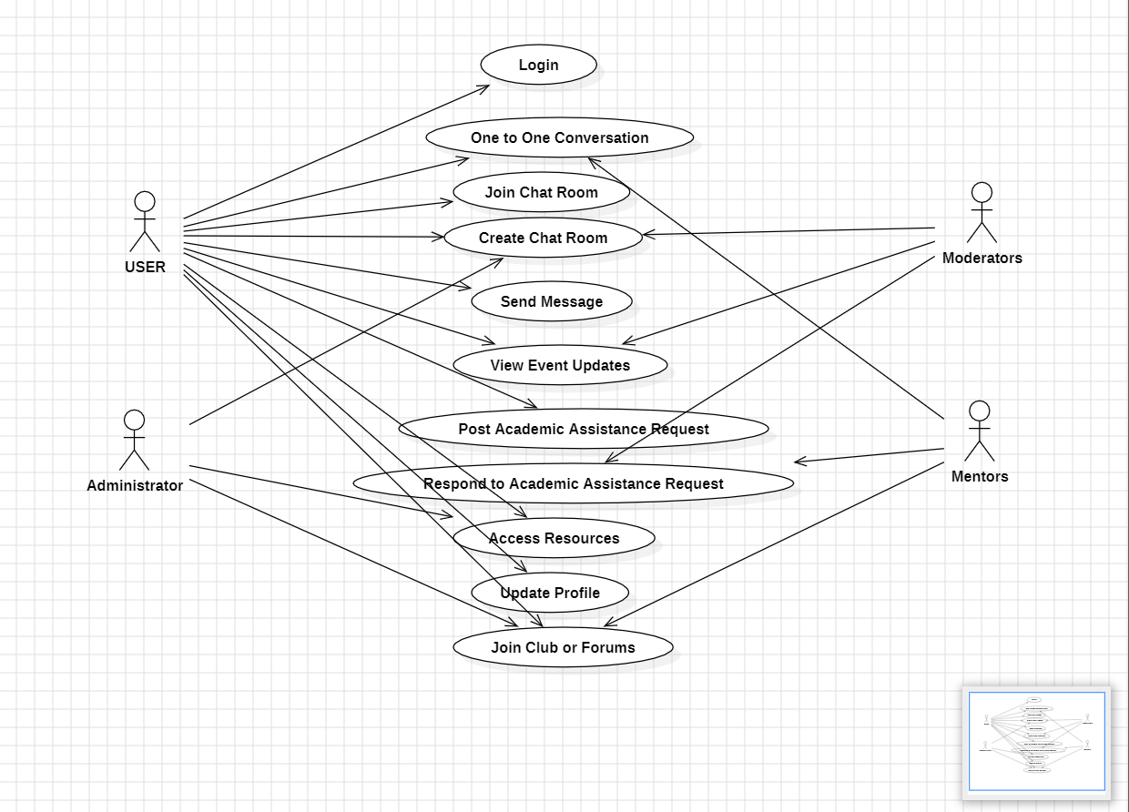

**Architecture Diagram:**

The architecture diagram provides a high-level overview of the system components and their interactions within VITMeet.

Components:

User Interface: Frontend interface for users to interact with the platform.

Application Layer: Backend logic for processing user requests and managing data.

Database: Storage for user data, chat logs, event updates, and system configurations.

Web Server: Hosts the platform and serves web pages to users.

Networking: Facilitates communication between clients and servers.

Interactions:

Users access the platform via web browsers or mobile apps.

Requests are routed to the application layer, which processes them and retrieves or stores data from the database.

The web server handles incoming HTTP requests and serves dynamic content to users.

Networking protocols ensure secure and reliable communication between clients and servers.

Scalability:

The architecture supports horizontal scaling by adding more servers or instances to handle increased traffic.

Load balancing distributes incoming requests across multiple servers to optimize performance and reliability.

Data partitioning and replication strategies are implemented to ensure data consistency and availability.

Security:

Security measures such as encryption, authentication, and access control are enforced at various layers of the architecture.

Firewalls and intrusion detection systems protect against cyber threats and unauthorized access.

Architecture Diagram: [Insert architecture diagram image here]